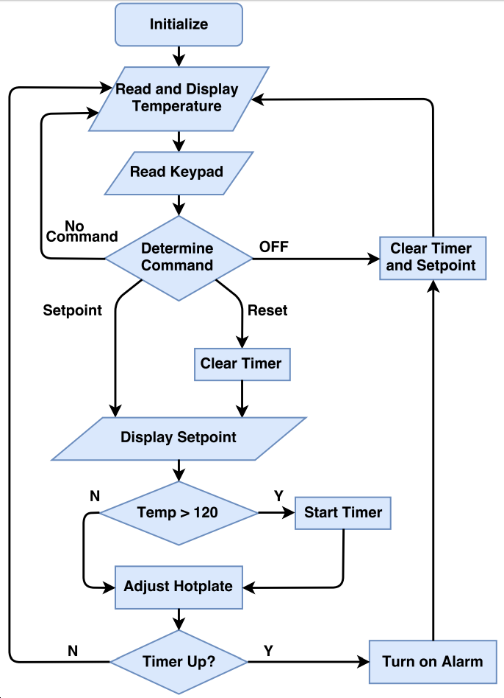

**Granny Safe Software Flow Chart**